**Question 1) Create a file empdata.dat containing fields such as employee code(alphanumeric), employee name(character), Department code(MKT,HRD,PUR), Grade(A,B,C), Experience(numeric), Basic Pay(numeric).**

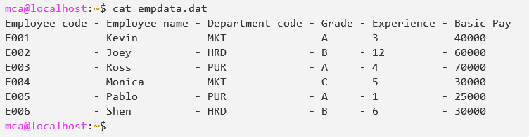

**- Display all employees who belong to MKT department.**

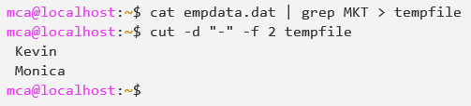

**OR**

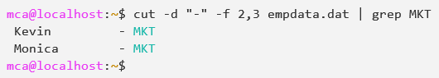

**- Apply sorting on department and grade column.**

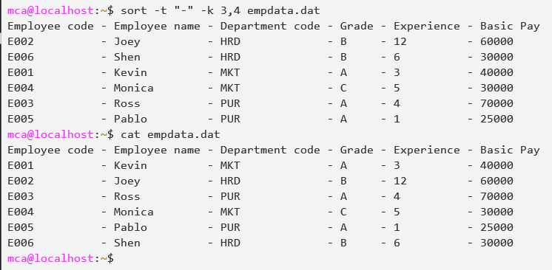

**- Display the name of the employee with highest basic pay.**

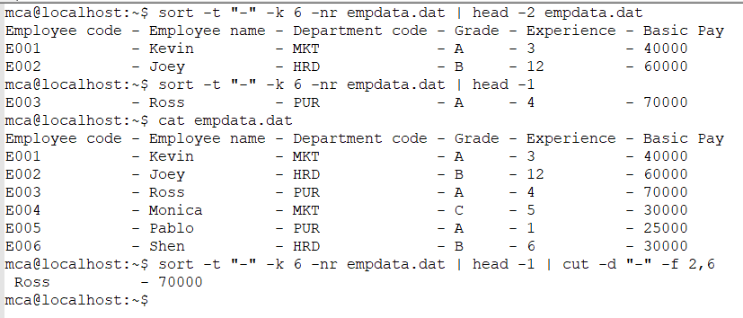

**- Display the details of the employee with least experience.**

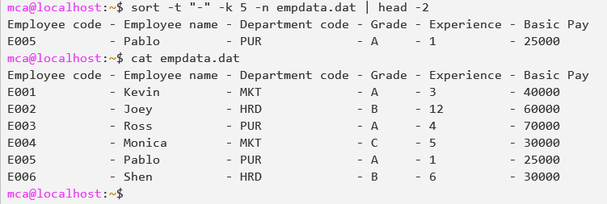

**- Display the list of employees where the employee name begins with "P".**

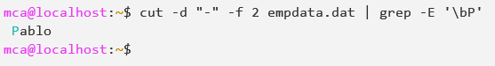

**Question 2). Create a file item.dat with the following fields having the mentioned type of values. Field names: Item code(Numeric), Item name(Character), Price(Numeric), Quantity(Numeric). Insert at least 5 records in the file separated by “:”.**

* **Sort items according to their prices.**

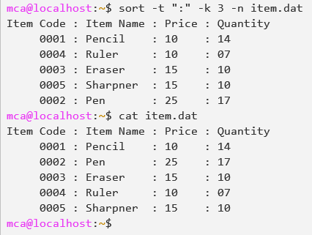

* **Display the record of the item with the highest quantity.**

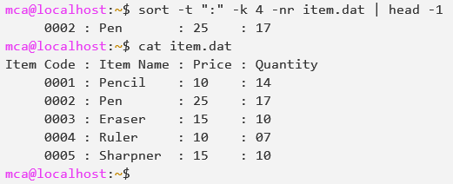

* **Sort the records according to their names in descending order.**

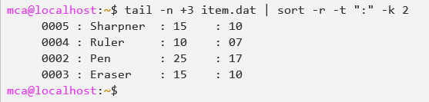

* **Display the record where item name begins with P.**

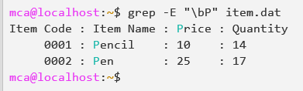

* **Display the record of the item with the least price.**

